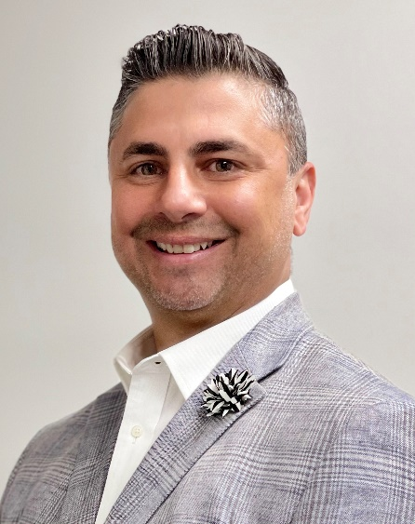

William Manzie is Administrative Director of Telehealth Strategy for the Memorial Healthcare System (MHS) and a past member of Florida Governor Rick Scott’s Telehealth Advisory Council. For Memorial, he blends strategic vision, strong clinical and technical backgrounds, a profound understanding of finance and operations to implement technology that delivers an improved healthcare experience.
William believes in upgrading healthcare by focusing on the triple aim and creating innovative concepts with technology to drive that change. He has been leading the charge in telehealth program strategies since 2011 and sees no end to this passion.
Manzie holds Bachelor’s Degree in Information Technology and Master’s Degree in Business Administration. He began his healthcare career in 1992 and held a variety of positions prior to focusing on telehealth strategy development, performance improvements, and patient satisfaction using telehealth. He has overseen the introduction of “MemorialDocNow,” an app that provides 24/7 online access to a doctor for non-emergency care, and has implemented several programs to make healthcare more accessible and convenient for the consumer.
He recently was showcased on the cover of Health Leaders magazine and has presented as a telehealth subject matter expert in conferences around the country.

# # #

