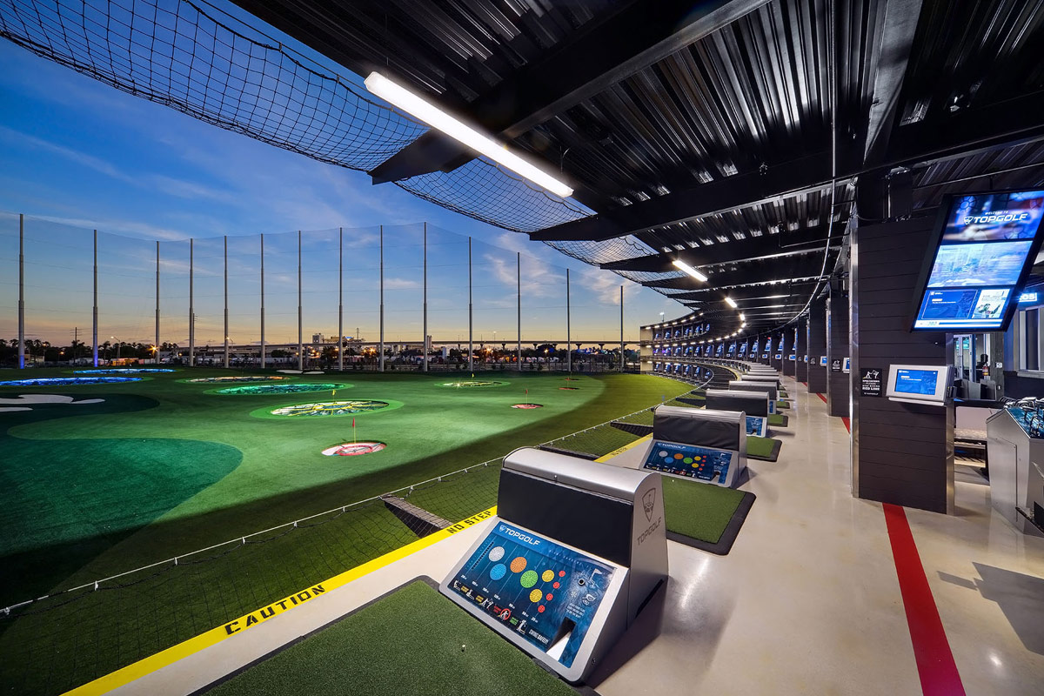
7th Annual Golf
Student Scholarship Fundraiser
Tuesday, June 11
Registration Opens - 3:45PM
Golf - 4:00PM-7:15PM

Corporate Sponsorship Packages

Type | Sponsor Investment | Benefits | Goody Bag Drop (Sponsor) | Event and Media Pages | Logo Recognition on Media Screens | Sponsor Board | Golfers Included
Signature | $2,500 | 5 minutes to introduce your company during Kick-off | ✓ | ✓ | ✓ | ✓ | 2
Trophy | $2,000 | Trophy + Opportunity to Present Winners | ✓ | ✓ | ✓ | ✓ | 2
Beverage | $1,500 | Beverage Sponsor Can place Banner in event | ✓ | ✓ | ✓ | ✓ | 2
Dinner | $1,500 | Dinner Sponsor Can place Banner in event | ✓ | ✓ | ✓ | ✓ | 2
Photo | $1,500 | Logo on Photos for all Social Media and website content | ✓ | ✓ | ✓ | ✓ | 2
Goody Bag  (10 Available) | $500 | Bag Drop Item | ✓ |  |  | ✓ | 1

SFLHIMSS 8th Annual Golf Tournament Sponsorship Commitment

Complete, execute and return this page to Lou Mendez at Lucianil.Mendez@crowncastle.com

BUSINESS NAME: Click here to enter text.
CONTACT: Click here to enter text.
STREET ADDRESS: Click here to enter text.
CITY: Click here to enter text. | STATE: Click here to enter text. | ZIP: Click here to enter text.
PHONE: Click here to enter text. | ALTERNATE PHONE: Click here to enter text.
EMAIL: Click here to enter text.

Select Below | Sponsorship  Type | Sponsorship Investment | Benefits
SOLD | Signature Sponsor | $2,500 | Golden Eagle Sponsor
SOLD | Trophy Sponsor | $2,000 | Trophy Sponsor
SOLD | Dinner Sponsor | $1,500 | Dinner Sponsor Can place Banner in event
SOLD | Beverage Sponsor | $1,500 | Beverage Sponsor
☐ | Photo Sponsor | $1,500 | Logo on Photos for all Social Media and website content
☐ | Good Bag Sponsor | $500 | Bag Drop Item (9 available)

☐ I would like to pay via credit card. Please send an invoice to: Click here to enter text.

☐ I would like to pay via check.

CHECKS ARE MADE PAYABLE TO: “South Florida HIMSS Chapter”
Mail the completed form and check to:

SFLHIMSS
Attn: Jorge Rey
One Town Center Road, Suite 400
Boca Raton, FL, 33486

